Booking System for Rodney Quarcoo.

Following our conversation the aim of this document is to outline the different features needed to build a complete booking solution.

Objective:

Rodney Quarcoo, a professional photographer and photography trainer is looking for a customer booking solution that helps him manage group training sessions, 1:1 consulting sessions and any other type of events using a simple and intuitive calendar interface.

The system has a few requirements outlined below:

* **Rodney should be able to set working hours**: We define working hours in the system as hours during which anyone interested in booking him for a session can do so.
* **Booked time slots will appear as unavailable once payment has been confirmed**: Once a client pays for their booking session, that slow becomes unavailable on the booking calendar.
* **Rodney should be able to create events:** Aside from 1:1 sessions, Rodney also offers group sessions. He should be able to create events and set ticket prices, dates and durations.
* **Events timeslots become unavailable after they have been created:** Once an event is created, the timeslot from that event becomes unavailable on the booking calendar.
* **Rodney should be able to offer discount & gift vouchers:** A discount would be similar to an early bird offer, e.g. “first 5 to buy get 15% off”, or give a code buyer can enter to apply discount. Or someone can buy a “gift voucher” that one can enter into system to apply “gift”.

Based on the requirements above, there are 2 types of users:

* Admin: Rodney’s role (possibly with a feature to add more admins)
* User: Customer looking to book a slot

On the User’s side, they should be able to do the following:

**View Calendar**: The calendar allows a user to view all slots that are booked and what slots are available.

Here’s an example from Calendly.

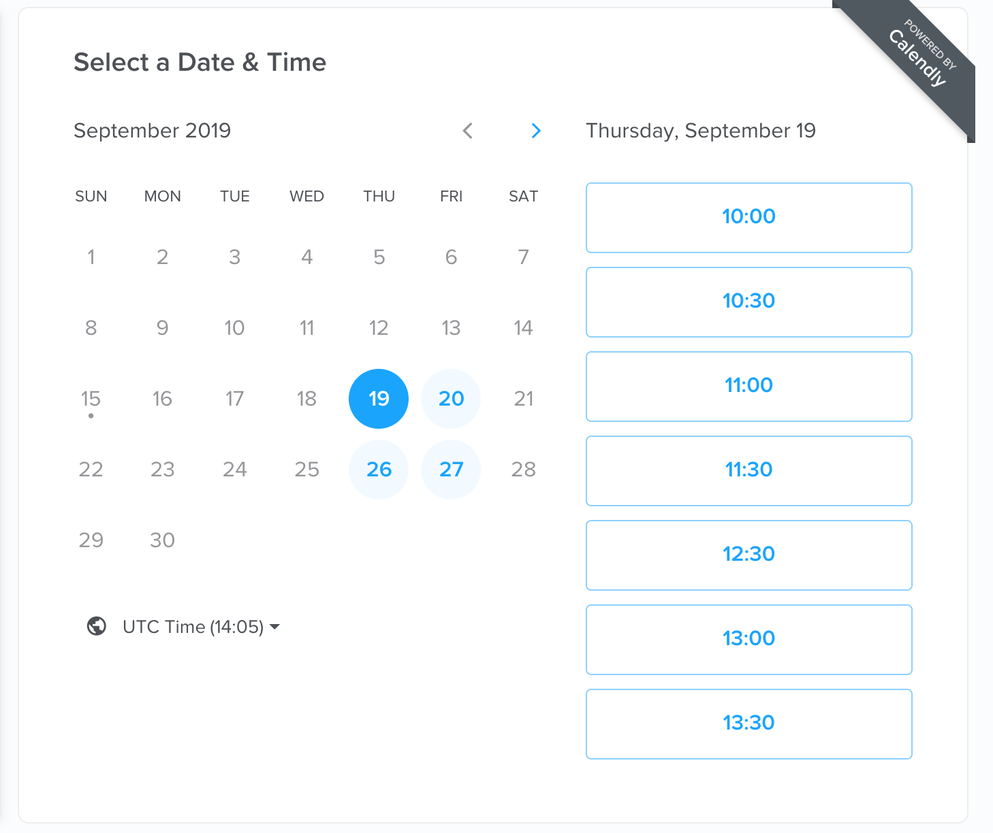

Unavailable slots will automatically be unclickable, and available slots will be clickable. If there is an event on a selected date, the slots during which the event takes place will also be unavailable.

**Pick Available Slot:** A user will be able to pick a slot and be taken to a page where they can enter a description of what type of training they are looking for. (Should this be a pre-selected list instead?)